TASK 1 – Understand the Problem and Identify the Data

1.1 Problem analysis
The Grama Jyothi Rural Electricity Co-operative needs a reliable C program to calculate electricity bills for households. The existing spreadsheet sometimes produces incorrect totals, negative bills after meter rollover, and inconsistent results after tariff changes. The program must calculate the correct bill to the nearest paisa.
Inputs and outputs
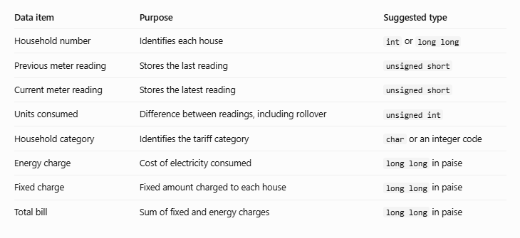
Constants
The following values should be defined once and reused:
- First slab limit: 100 units.
- Second slab limit: 200 units.
- First slab rate: ₹0 per unit.
- Second slab rate: ₹2.25 per unit.
- Third slab rate: ₹4.50 per unit.
- Fixed charge: ₹50 per bill.
- Meter register maximum: 65535 for a 16-bit meter.
Rules for a correct bill
- The total bill must equal the energy charge plus the fixed charge.
- The bill must never be negative.
- The first 100 units are free of energy charges.
- Units from 101 to 200 cost ₹2.25 per unit.
- Units above 200 cost ₹4.50 per unit.
- A meter rollover must be handled correctly.
- Money must be calculated without floating-point rounding errors.
- Invalid input must be rejected.
Assumptions
- The meter register has values from 0 to 65535.
- One rollover occurs between the previous and current readings.
- The fixed charge is ₹50 for every bill.
- Tariff rates remain the same during one execution of the program.
- Each unit represents one kilowatt-hour for the original billing system.
- A reading that is lower than the previous reading is treated as rollover only when the meter's rollover rule applies.
1.2 Alternative concept and complexity analysis
If readings were stored as character strings, a reading such as 01530 would be preserved exactly as entered. The program would need to validate the digits and convert the string into an integer before calculating consumption.
Let \(d\) represent the number of digits in a reading.
- Integer representation: Reading and comparing values take \(O(1)\) time for fixed-size integer types. The storage size is fixed.
- String representation: Validating and converting a reading generally takes \(O(d)\) time. Storage is \(O(d)\), including the terminating null character.
- Conclusion: Integer storage is suitable for calculations. Strings are useful for preserving the original input format, but they need validation and conversion.

